**Organic Vegetable Gardening: A Five-Part Series in Growing Your Own Food**

Wed, Feb 27th, 2019, 6pm to 8:30pm

Marybeth Janerich, Community Education Program Director, Wasatch Community Gardens

* Class # 3: Wednesday, March 7, 6-8:30
  + Intensive planting methods including vertical gardening, succession planting & crop rotation
  + Elements of ongoing garden care, including fertilizing, watering, thinning, mulching
* Class # 4: Saturday, March 10, 10-12 (at Grateful Tomato Garden)
  + Site visit at Grateful Tomato Garden
  + Garden planning and design
* Class # 5: Wednesday, March 14, 2018, 6-8:30
  + Problems in the garden/organic pest management
  + Gardening resources and ongoing learning opportunities

**__________________________________________________________________________________________**

**Getting the most out of our garden space**

If we had all the room in the world to grow our food, we wouldn’t need to think about how to make the best possible use of the space we have.

Most of us grow in limited space, and we can make better use of our space and have more productive & healthy gardens if we incorporate the following methods:

* Succession Planting
* Crop Rotation
* Companion Planting
* Vertical Growing/Vertical Gardening

**Succession Planting**

Method # 1: Planting a crop, such as lettuce, one or several rows at a time so that the whole crop doesn’t mature at once.

* + - Ex: Plant a bit of lettuce, then wait a few weeks, and plant some more. This extends the harvest over time.
    - Follow a planting chart for when and how to plant
      * See last page of handout; visit this link, https://parkseed.com/vegetable-guide/a/vegetable-planting-guide/

Method # 2: Planting a crop in a space made available once another crop is harvested.

* + - Ex: Plant all your lettuce at once, or succession plant it in spring. Once spring-planted lettuce is all harvested, or the heat in June makes the plants “bolt,” or go to seed, then plant a warm-season crop of bush beans or cucumbers in the space where the lettuce was for a “succession” crop. Makes more use of that garden space!
    - Ex: Sequence of Spring Lettuce –> Summer Bush Beans –> Fall/Winter Kale (started in seed trays or bought as starts)

Succession planting keeps you in veggies the whole season long and keeps the weeds at bay by never letting an area of the garden go fallow (unplanted). Can also succession plant with a cover crop.

* + - Ex: Sequence of Spring Lettuce –> Summer Bush Beans –> Fall/Winter Hairy Vetch & Winter Rye cover crop

**Crop Rotation**

The practice of switching crops grown in the same space to (1) benefit soil fertility and (2) reduce pests and diseases from building up (remember plant families?).

Can be challenging for a small home garden, but worth knowing about.

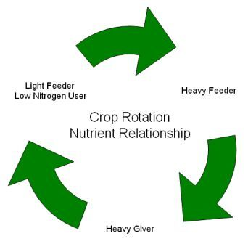

* **Light to Moderate Feeders** include many salad and root crops (e.g., lettuce, carrots, radishes)
* **Heavy Feeders** include tomatoes and other solanaceous veggies, corn, and brassicas (e.g., kale)
* **Heavy Givers** = legumes such as peas and beans

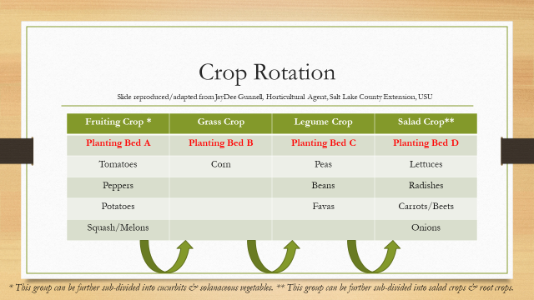

If you only have one or two garden beds, this becomes really tricky! Cover cropping can become even more important in that kind of scenario to maintain excellent soil health and fertility.

* **Top Tip**: GROW LOTS OF PEAS AND BEANS! Plant them in different beds or different spots in each bed each year to the degree possible.
* Don’t let crop rotation get you down!
* Also remember the rhyme: **Beans • Roots • Greens • Fruits**!

**Companion Planting**: Folklore vs. Fact

* Folklore: Historical tradition passed from generation to generation, neighbor to neighbor
* Fact: There are some valid mechanisms of certain plant associations that can lead to minor pest suppression and greater crop yields.

Types of Companion Planting

* **Nurse cropping** uses tall plants as shade or wind protection for other plants.
* **Inter-planting or inter-cropping** can confuse insect pests.
* **Trap cropping** is using a sacrificial crop to attract insect pests away from the crop(s) you care about.
* **Pest suppression:** 
  + French Marigolds secrete/exude compounds that suppress or repel certain insects. Great companions in the garden for tomatoes and other crops! Marigolds are especially effective against soil-dwelling nematodes (which can damage tomato plants) and cabbage worms (adult cabbage moths that love to eat cabbage plants).
  + Nasturtiums attract hover flies that eat aphids ☺
* **Attraction of pollinators:** Including certain flowers in your garden likely to bring bees, birds.
  + Sweet alyssum
  + Zinnias
  + Dahlias
  + Sunflowers
  + Herbs (thyme, oregano, basil, mint, hyssop – allow some to blossom!
* **Compatibility –** see companion planting chart at end of handout
* Don’t get overwhelmed!
* Plant your garden this year. Plant something, somewhere. Love it and enjoy it!
* Pay attention to soil quality, getting healthy transplants, and keeping things watered correctly.
* Write down where things were in the garden and how they did.
  + Importance of garden journaling!

**Vertical Gardening**

* Reasons to grow vertically
  + Save Space
  + Easier harvest
  + Increased Air Flow
  + Decreased Risk of Pests and Disease
* Be creative. Use what’s available or what suits your fancy.
  + Electrical conduit and trellis netting (square foot gardening book)
  + Teepees
  + Wire cages
  + Bicycle wheel frames tied together vertically and zip tied to a T-stake
  + Chain link fencing
  + Super sturdy cages made inexpensively from concrete reinforcing mesh with 6” squares. Available at home improvement centers in 4’ x 7’ sheets. Form into columns and attach with metal ties or zip ties to T-stakes to create inexpensive & durable structures.
    - Use for tomatoes, pole beans, cucumbers, and vining winter squash.
    - We will see this type of cage at the Grateful Tomato Garden on Saturday.

Fertilizing

N – P – K

* + Nitrogen – Phosphorus – Potassium
  + **Macro**nutrients
  + Ex: 5-5-5 is a balanced fertilizer, equal percentages of N, P and K
  + Ex: 20-5-5 has four times more nitrogen in it than phosphorus and potassium
  + The numbers are always in the same N-P-K order, whether on a chemical (synthetic) or organic fertilizer

**N=Nitrogen** – needed for GREENING/GROWTH/LEAVES

**P=Phosphorus** – needed for ROOTS/FLOWERING/FRUITING

**K=Potassium or Potash** – needed for STRONG EARLY GROWTH/OVERALL FUNCTIONS/ STALKS/ VIGOR/DISEASE RESISTANCE/MAXIMIZES FLOWER NUMBERS

* + Potassium levels are usually high in Utah soils
  + Remember new article from USU about high P and K in composted manure. Even homemade compost is very high in P and K. Fine to use 2-3” per year in newer gardens that need abundant organic matter added. Apply less in more established gardens with adequate amounts of organic matter.
* **Fertilizers must be applied according to the label instructions**!
* More is NOT better! Same goes for pesticides and herbicides ☺
* For detailed information about HOW to fertilize, WHEN to fertilize, and HOW MUCH to fertilize different crops based on their specific needs (such as heavy feeders), visit [**www.garden.usu.edu**](http://www.garden.usu.edu/) or refer to that particular vegetable’s **fact sheet**.

How do we apply fertilizer?

* Home gardener application methods:
  + **Bed Prep:** work into soil before planting
  + **Broadcasting**: spread over the area at label rate and incorporate into soil
  + **Side dressing**: apply dry fertilizer after plants are growing. Scatter on both sides 6-8” from plant(s) and water in.
  + **Foliar feeding**: apply liquid fertilizer via watering can or hose attachment directly to leaves.
    - \***Supplemental only** – not a substitute for **soil** nutrition. Worm tea probably the best, per USU latest research.

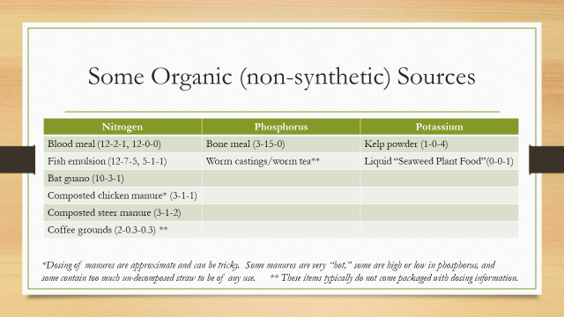

* If you have a USU Extension soil test performed, you will receive recommendations for inorganic/synthetic fertilizer application.
  + Ex: Apply 3 lbs. Nitrogen to 1000 square feet.
  + If using blood meal, which is 12-0-0, the math boils down to 2.5 lbs. of BLOOD MEAL per 100 square feet.
* If you’re confused about their recommendations, **call USU Extension if questions**, **385-468-4828.**
* Refer to USU Extension Fact Sheet, “Calculating Fertilizer for Small Areas,” which also has a hyperlink to a formula that does the math for you. You just plug in your garden’s width and length, and it does the rest!

**Watering**

* Germinating seeds:
  + Ensure good seed-to-soil contact.
  + Must never dry out while seeds are trying to germinate.
* Young seedlings have very shallow roots, requiring more frequent watering (and even more frequent on hot, windy days b/c of evaporation).
* More mature plants can be watered more deeply and less frequently.
* If hand watering, such as early season, water gently and with confidence!
* Use shower nozzle-type watering can or spray mister to avoid washing away surface-sown or shallowly-planted seeds.

How much to water?

Everyone asks how often or how much they should water. Everyone’s growing situation (soil) will be different.

Slope, temperature, WIND and soil type affect how much you will need to water.

* On average, 1” of water applied to surface reaches 12” down in sand, 7” down in loam, 4-5” down in clay. This may differ wildly from the situation in your garden! Do some tests!

Watering Methods

* Hand watering – great for newly-seeded beds, new transplants, container plants
* Overhead watering/sprinklers – easy but wastes water, encourages leaf diseases – use early morning
* Flooding, furrows – row crops; use in conjunction with hand watering
* Soaker hoses
* Drip irrigation – most preferred, most efficient, most work and cost to set up.
  + A well-designed drip irrigation system will save water and helps to reduce disease in the garden by keeping leaves dry.
  + Can be set up with timers
  + Does not water the pathways or the weeds
  + Can cover the drip tape with mulch
  + Kathlyn Collins is The Gardening Coach. Visit www.thegardeningcoach.net for info on supplies, help with setting up drip systems

**Thinning and Mulching – a Whirlwind Tour!**

**Thinning**

* After the second set of true leaves have emerged, thin seedlings to appropriate plant spacing to allow for proper growth.
  + What the heck is a set of true leaves? What are cotyledons?
* Trim with small scissors rather than pulling to avoid disturbing roots.
* Sowing seeds more carefully reduces the thinning to be done later –and reduces the number

of seeds you need – remember Mb’s friend’s first attempt at sowing carrots (whole pack of seeds in about a 2’ row!)

**Mulching**

* The practice of applying organic or inorganic materials to the soil surface to retain moisture and suppress weeds
* Types of mulch:
  + Shredded bark (not great for gardens – why?), straw (NOT hay!), compost, chopped leaves
    - Source straw carefully – choose weed free!
  + Paper mulch (commercial, or newspaper)
  + Plastic mulch (black or green) warms the soil. Helpful for warm-season crop plantings of squash and beans.
  + Silver reflective mulch good for confusing pests and can increase pepper production by 20%.
    - Black and silver mulches will be used in the teaching/demo gardens this summer, so stop by the garden at some point this summer and check them out
  + Red plastic “selective reflecting mulch,” or SRM-Red, for tomatoes, said to increase production compared to black plastic

**Next Saturday, March 9, is our FIELD TRIP to the GRATEFUL TOMATO GARDEN!**

* Garden Planning and Design
* Bring a sketch of your garden!
* Address of Grateful Tomato Garden:
  + 615 E 800 South
  + Northeast Corner
  + We’ll meet by the greenhouse!
  + Park along 800 South or 600 East – carpool?
  + Sunscreen, hat, water bottle - OR hat, coats and gloves. Check the weather!

**Next Wednesday evening, March 6th, is our last session. We’ll cover:**

* Problems in the garden – not if, but when ☺ and that’s OK!
* Environmental Issues
* Biological Issues
  + Insects
  + Diseases
* Resources for diagnostics